 

UNIVERSITY INSTITUTE OF COMPUTING

**PROJECT REPORT**

**ON**

**FOOD BROCHURE**

Program name: BCA

Subject Name/Code: Desktop Publishing

Lab(23CAP-204)

**Submitted by: Submitted to:**

**Name:** Nargis Parveen **Name:** Ms. Pardeep Kaur

**UID:** 23BCA10434 **Designation:** Assistant

Professor

**Section:** BCA – 9(A)

ABSTRACT

Introduction of Adobe Photoshop:

Adobe Photoshop is a critical tool for designers, web developers, graphic artists, photographers, and creative professionals. It is widely used for image editing, retouching, creating image compositions, website mock ups, and adding affects.

* **Uses**: Photoshop is used for a variety of tasks, including:
  + Retouching images
  + Correcting lighting
  + Adjusting photo composition
  + Creating image compositions
  + Adding effects
  + Creating website mock ups
  + Creating website layouts

**. Required Tool Used in:**

* Rectangle Tool
* Text Tool
* Move Tool
* Triangle Tool
* Background Tool
* Pen Tool

**Steps:**

* 1. Firstly create the new document with the width 1091, height 2552, in pixels.

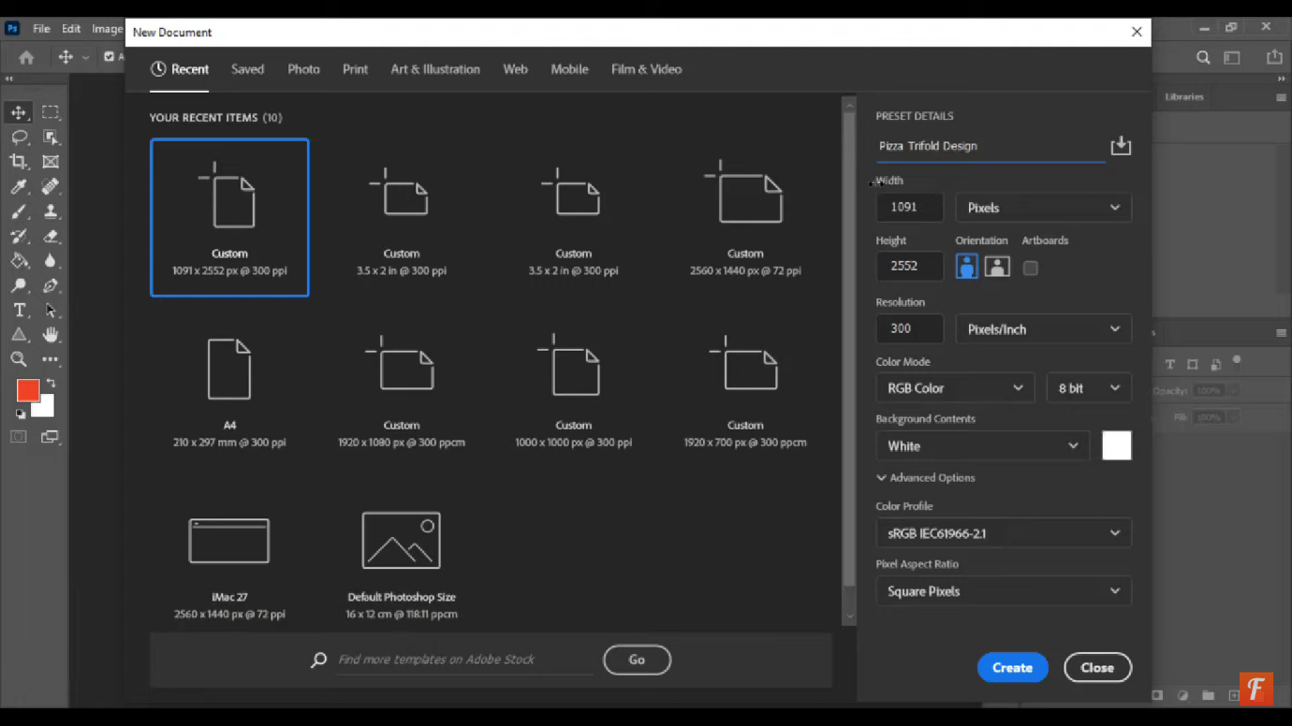

* 1. Go to the view option, choose the New guide layout then divide the custom in 3 columns.

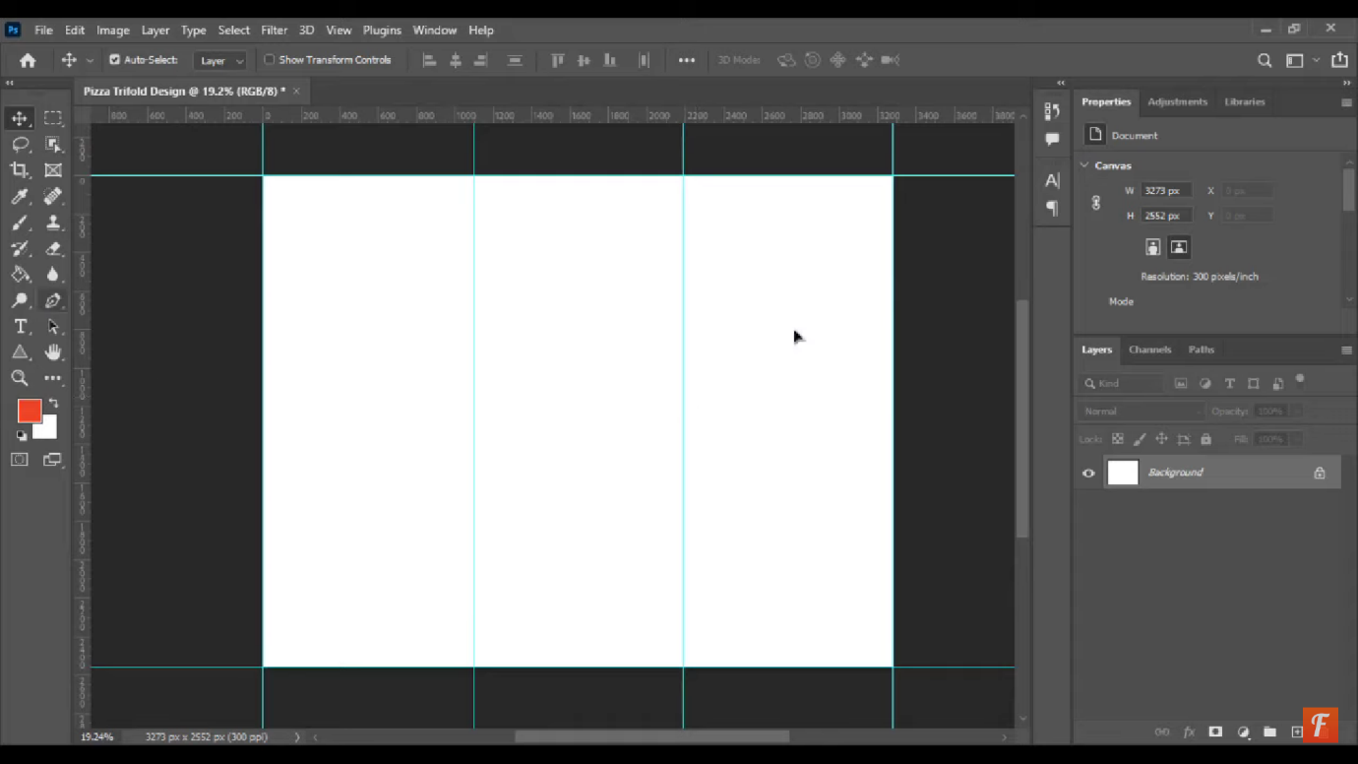

* 1. Select the pen tool draw the design and then choose selective colour to fill the colour.

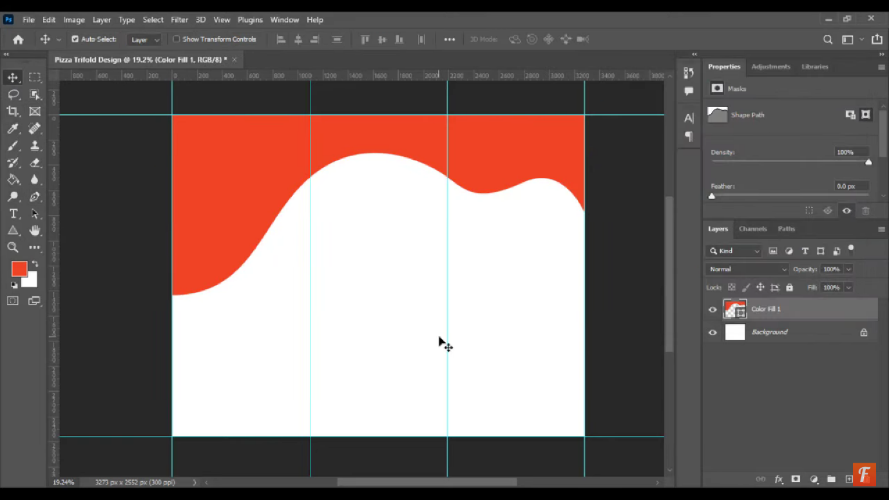

* 1. Select the layer and choose the Rectangle tool and choose the selective colour.

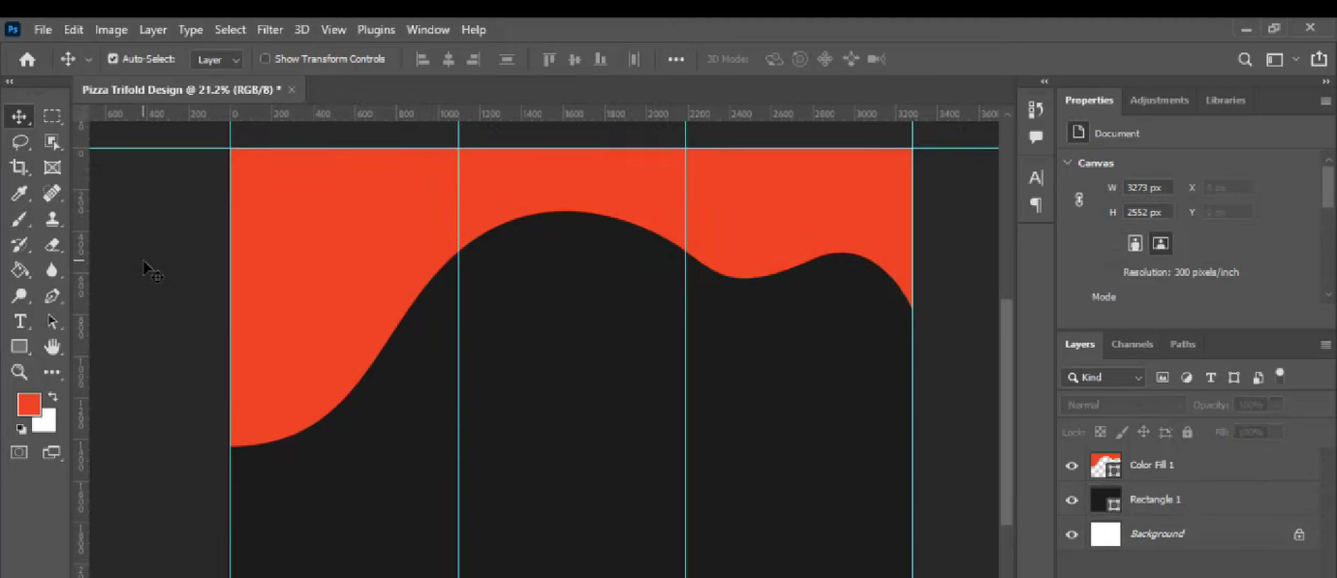

* 1. Go to the file. Choose the place embedded option.Go to the file and select the option and paste the picture with fix size.

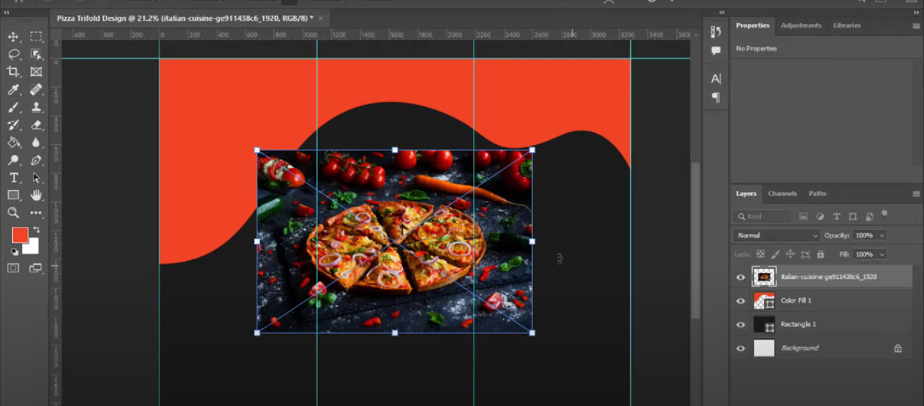

* 1. Select the layer and Choose the text tool. Write the text and select the writing style with colour.

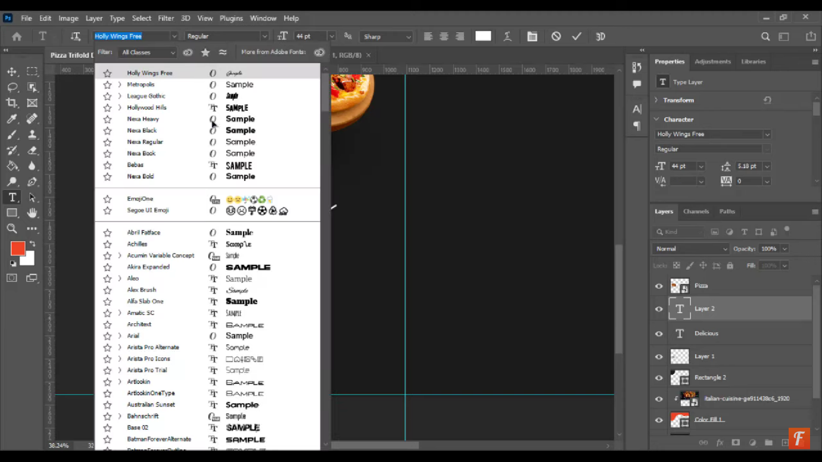

7.In last step choose all image and paste in it write all text and design the brochure with logo.

